EXERCISE 1
- Write a complete SQL Statement for creating a new database called addressbook.
Answer: CREATE DATABASE addressbook;
- Which statement is used to list the information about a table? How do you use this statement?
Answer: DESCRIBE table_name;
This statement can be used by declaring the command “DESCRIBE” followed by the name of the table that you want to display details.
- How would you list all the databases available on the system?
Answer: SHOW databases;
- Write a statement for inserting the following data in the employee_data table
First name: Rudolf
Last name: Reindeer
Title: Business Analyst
Age: 34
Years of Service: 2
Salary: 95000
Perks: 17000
Email: rudolf@bugnet.com

Answer:
INSERT INTO employee_data (f_name, l_name, title, age, yos, salary, perks, email)
VALUES ('Rudolf', 'Reindeer', 'Busines Analyst', 34, 2, 95000, 17000, 'rudolf@bugnet.com');
- Give two forms of the SELECT statement that will list all the data in the employee_data table.
- SELECT * FROM employee_data;
- SELECT f_name, l_name, title, age, yos, salary, perks, email FROM employee_data;
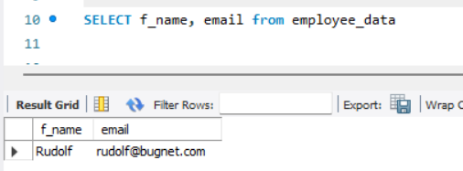
- What will select f_name, email from employee_data; display?

- Write the statement for listing data from salary, perks and yos column of employee_data table.
Answer: SELECT salary, perks, yos FROM employee_data;
- How can you find the number of rows in a table using the SELECT statement?
Answer: SELECT COUNT(*) FROM table_name;
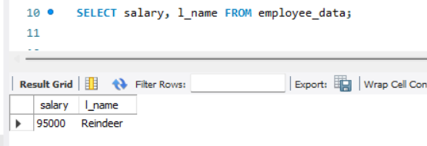
- What will select salary, l_name from employee_data; display?

